Test system to measure capture efficiency of petrol vapour recovery during refuelling of motor vehicles.
With aim to reduce air pollution the European Union made effective on October 21, 2009 the Directive of the European Parliament and of the Council no. 2009/126/EC on Stage II petrol vapour recovery during refuelling of motor vehicles at service stations. This Directive has introduced the following requirements:
1) Since January 1st, 2012 to equip all the new and existing service station undergoing a major reconstruction with Stage II petrol vapour recovery system. This requirement is mandatory for service stations specified as follows:
- Service stations with actual or intended annual throughput greater than 500 m³,
- Service stations with actual or intended annual throughputs greater than 100 m³ in residential or working areas.
In the CR such specification of throughputs embraces practically any mid-size service station.
2) By no later than December 31st, 2018 to equip all the existing service stations with annual throughputs greater than 3000 m³ with a Stage II petrol vapour recovery system.
Practically the only way how to meet the above mentioned requirement is to install in fuel dispensers a corresponding system of petrol vapour recovery system fulfilling the provisions of the corresponding European standard. For manufacturers of fuel dispensers it means that tests of the recovery system in a given type of fuel dispenser have to be made to prove that the requirements of the legislation have been met. Such standard, EN 16321, was released in April 2014 - its Part 1 sets down test and measurement methods and procedures for the type approval efficiency assessment of petrol vapour recovery systems.
CMI, on request from one of the manufacturers, started in the course of 2014 to develop, in line with the requirements of the standard, corresponding test system which would enable to carry out all the necessary tests in a full scale. When found that all the requirements are fulfilled it would be possible to issue to the applicant a certificate demonstrating conformance with the provisions of the Directive.
The test system enables to carry out the following tests:
- the test of efficiency of given petrol vapour recovery system for refuelling of motor vehicles at service stations. In principle, it is based on determination of the amount of hydrocarbons in the vapours by a gravimetric method;
- the test of petrol vapour/petrol ratio to find out the ratio of the volume of vapour recovered and that of released to the atmosphere during refuelling;
- the test of proportionality – the ratio of the volume of vapours recovered and that of released during the refuelling at various petrol volume flow rates;
- the correction factor determination for setting, self-test and monitoring of the petrol vapour recovery system by a “dry” method (using ambient air) on the site of its installation.
The system consists of various regulating valves, filters and measuring instruments interconnected by tubing. This set-up enables accurate measurements of recovered vapour volumes, a synchronization of the petrol delivery to the tank with the recovery system and an evaluation of the hydrocarbon mass fraction in petrol vapours. All the used measuring instruments are properly calibrated, as it can be expected in a national metrology institute, and the design and construction fulfils all the applicable safety regulations. The set-up is in the final stage of its development – after its finalization it will be certified for use in an explosive atmosphere (ATEX Directive). It is assumed that it will be put in a full-scale operation in mid-2015. All the elements of the test system can be accommodated in a trailer (see the picture below) to be transported to the site of the testing, alternatively the tests can be made on CMI premises, as agreed with the applicant (the manufacturer). In case of any interest in these matters please contact Mr. Peter Škrovánek at pskrovanek@cmi.cz or Mr. Jindřich Bílek at jbilek2@cmi.cz.
The test set-up with one of the tanks installed forms the main module which is accompanied by the other 2 testing tanks – see below
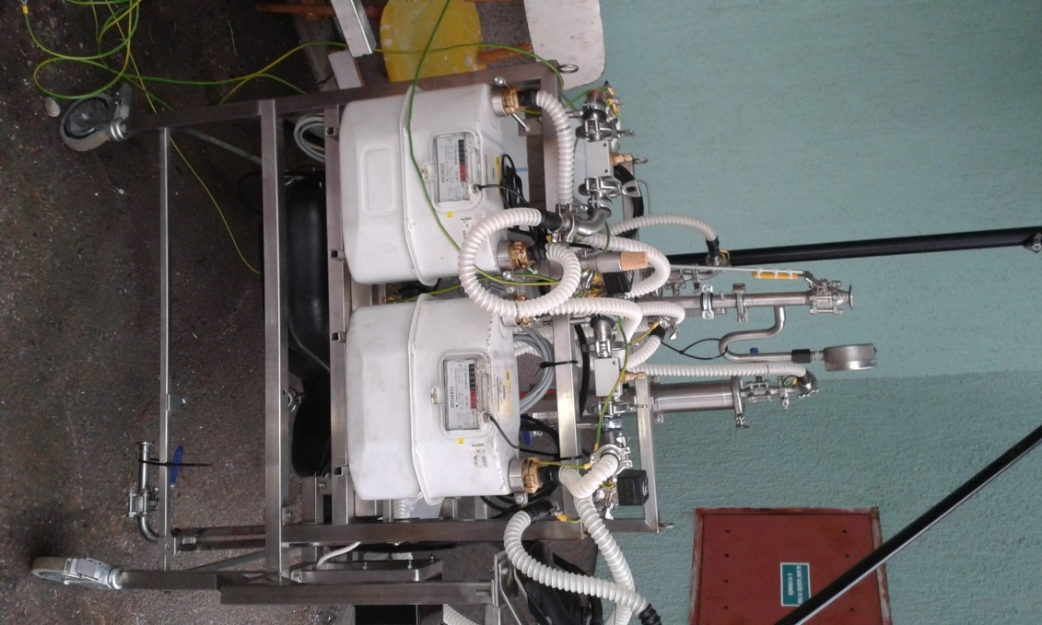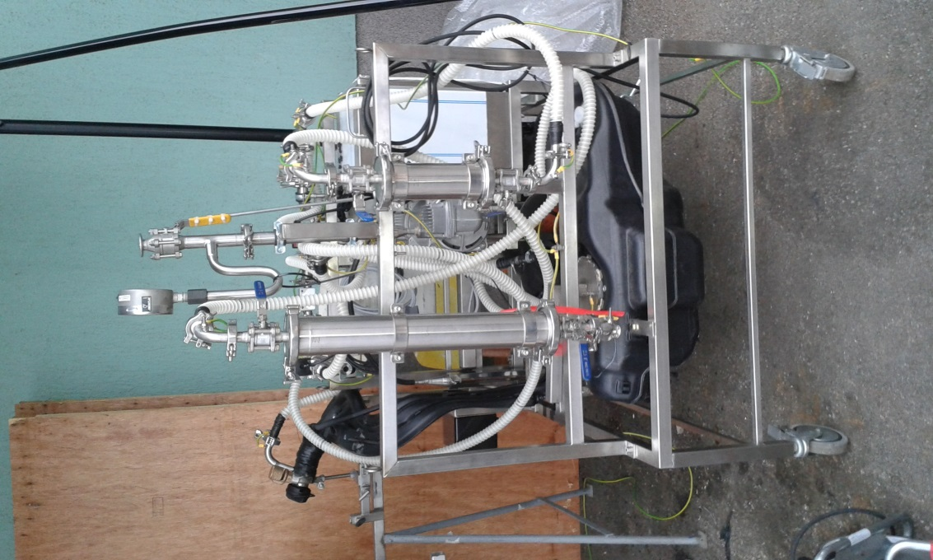

The additional automobile tanks needed to carry out of the required tests
