New CMI standard for pressures up to 1 GPa
With a high pace of the development of modern technologies the need of high accuracy calibrations at the extremes of the pressure scale is fast growing. CMI Regional Inspectorate Brno launched in January 2020 new metrological service – gauge pressure calibrations in oil medium up to 1 GPa. Until that time CMI had to rely its calibration services in the range of 500 MPa up to 1 GPa on a technically and morally obsolete device with currently unsatisfactory uncertainty of 0.2 % of the measured value (for k = 2). To overcome this deficiency a new piston pressure standard Aréméca BH5-10000B has been put in operation, traceable to the national standard of gauge pressure in the oil medium up to 500 MPa. The work on traceability, metrological analysis and extrapolation of uncertainties have led to an estimation of the achievable uncertainty of 0.025 % of the measured value in the pressure range of 500 MPa up to 1 GPa (for k = 2, not including the uncertainty component given by the device under calibration). Any standard types of deformation pressure gauges, digital pressure gauges, pressure transducers and piston pressure standards can be calibrated using this newly commissioned calibration system.

Basic technical parameters of the standard
Pressure range | 50 MPa – 1 GPa
Calibration and Measurement Capability - CMC | 0.025 % of the measured value
Dimensions | 65 cm x 55 cm x 40 cm (w x l x h)
Supply | 220 V / 50 Hz
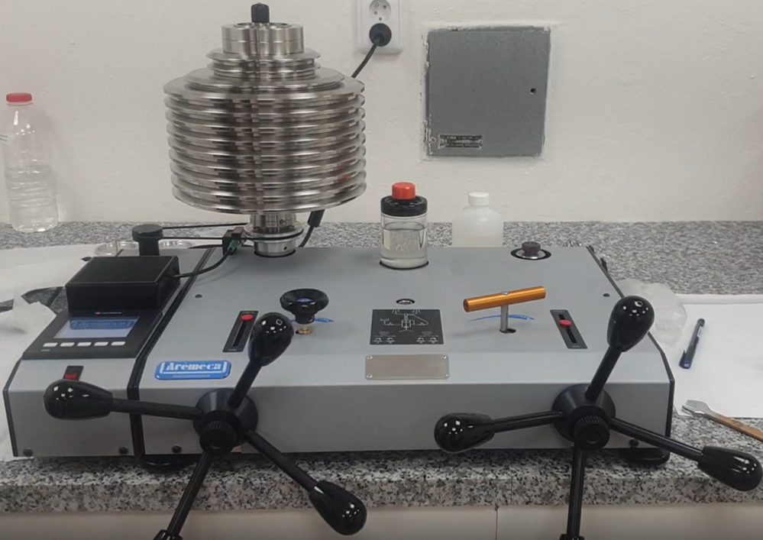

Any inquiries or requests for calibration quotes can be sent to Head of the Laboratory of pressure, vacuum and mass flow, CMI RI Brno:
Mr. Zdeněk Krajíček, PhD., zkrajicek@cmi.cz, +420 545 555 297

