New CMI piston prover for flowmeter calibrations for liquids other than water.
These days a new CMI piston prover as a mobile, transportable system has been put into operation. It will serve as a primary standard of flow for liquids other than water, especially hydrocarbons like various fuels. Its putting into operation will extend the current upper range of flowrates for calibration of flowmeters on site from 400 m³/h up to 750 m³/h. At the same time a special design feature employing 3 optical sensors to make measurements enables to reduce the measurement times in the range of low flowrates thus enhancing the effectiveness of the operation in comparison with the currently used piston prover.
The piston prover is intended to be used for calibrations, verifications and conformity assessment measurements of volume and mass flowmeters on site, e.g. on crude oil or product pipe lines, on tank loading racks and to provide metrological traceability to standards used for verification of LPG dispensers. The mobility of the prover is arranged for by mounting it on a trailer. The total mass of the trailer with the prover installed on it is approx. 6 t. An OMNI 6000 flow-computer is used to control the prover and to evaluate signals from both the standard and the unit under test.
Technical parameters of the piston prover are as follows:
minimum flowrate: 6 L/min
maximum flowrate: 750 m³/h
density range: (500 to 1200) kg/m³
temperature range: (0 to 80) °C
operational pressure: up to 5 MPa
The design of the prover is completely based on use of stainless steel inclusive connecting tubing and the particle filter. In the connecting tubing a bypass with a densitometer enabling mass flow measurements and with a circulatory pump to generate required operational conditions for the densitometer is installed.
The whole system is also certified for use in an explosive atmosphere (ATEX Directive).
The assumed uncertainty of calibrations is expected to be better than 0.05 %.
In case of interest please contact Mr. Jindrich Bílek, jbilek2@cmi.cz or Mr. Zdenek Toufar, ztoufar@cmi.cz.

A detailed view of the piston prover

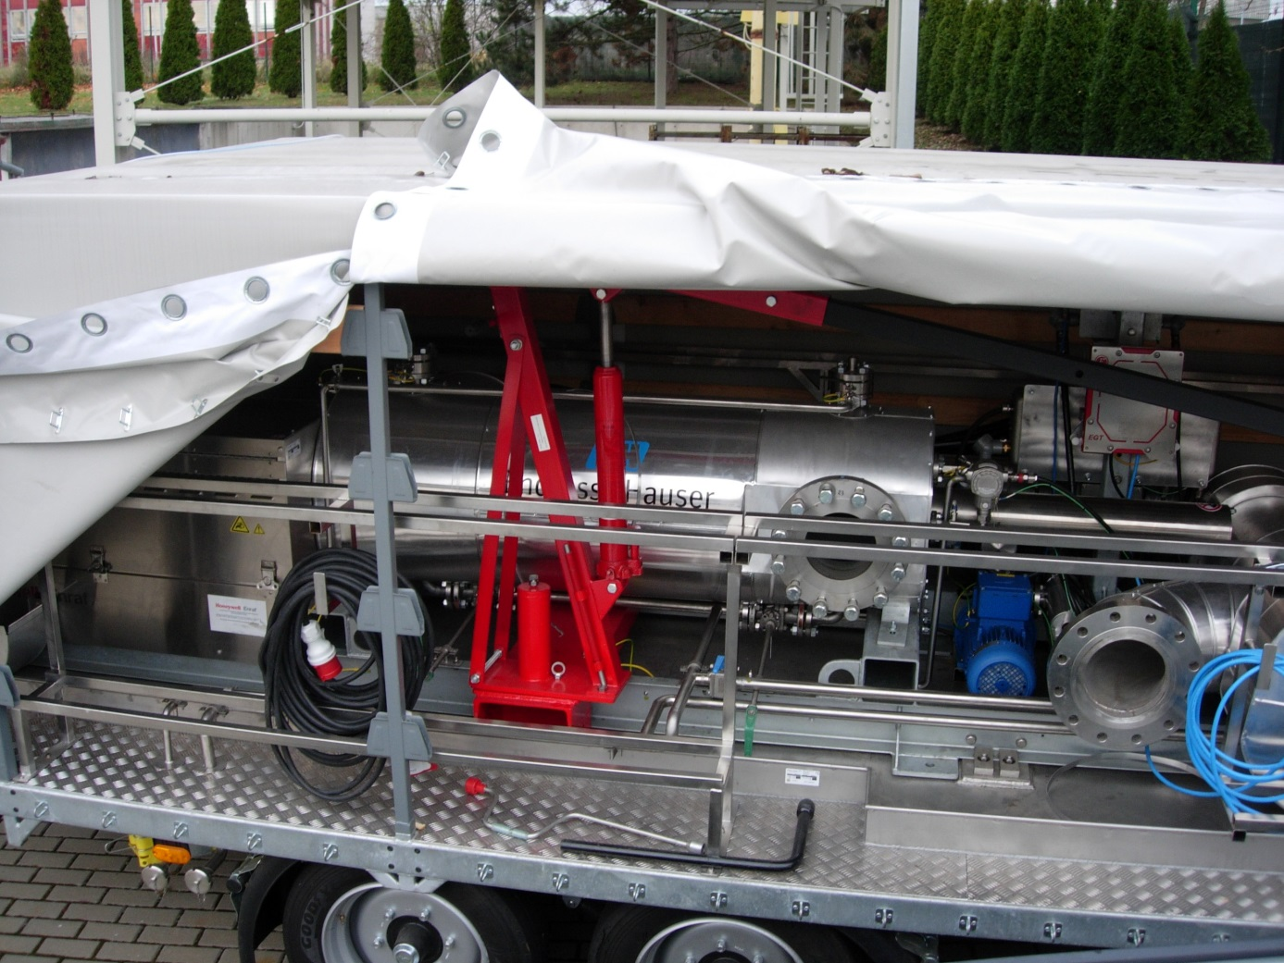

A view of the entire mobile system
