A New Measurement Device for Checking Electric Vehicle Charging Stations
In recent years, number of electric vehicles and public charging stations have raised also in Czech Republic. CMI follows this new trend metrologically in order to continuously expand its services according to the current customer requirements. A device for measurement of DC charging stations for electric cars was developed and constructed by the Department of primary metrology of electrical impedance and electrical quantities, CMI, Regional Inspectorate Prague. Now this department can offer measurement of the accuracy of charging stations equipped with CCS type 2 connector up to charging current of 200 A and voltage up to 850 V. The best measurement uncertainty of the energy delivered to the electric car is 0.2 % with a coverage probability of approximately 95 %. If necessary, it is also possible to measure the output voltage, current and power supplied to the electric car by the charging station.

Basic parameters of the measurement device
Charging current | up to 200 A
Charging voltage | up to 850 V
Best measurement capability of delivered energy | 0.2 % in reference conditions
Charging stand connector | CCS type 2
Type of charging voltage | direct
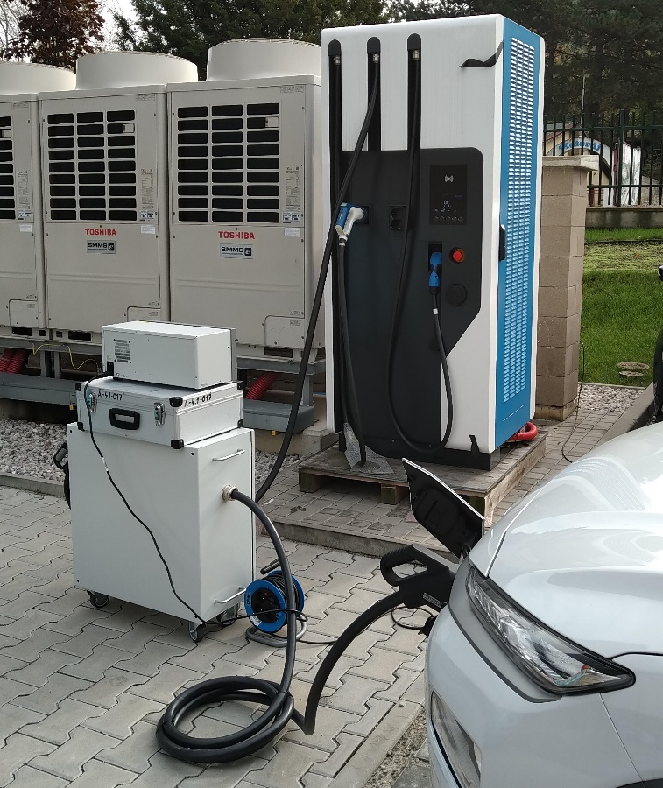

If you have any questions or are interested in measurements at DC charging stations for electric cars, please contact the specialists of the Prague Regional Inspectorate, Department of Primary Metrology of Electrical Impedance and Electrical Quantities:
Ing. Jiří Zikán, jzikan@cmi.cz, +420 266 020 161
Ing. Jan Chroust, jchroust@cmi.cz, +420 266 020 116

