New CMI reference standard for calibration of high-speed laser measuring instruments of length
Recently industry strives in the area of winded materials (cables, unwoven textiles) strives to achieve much higher productivity of labour, i.e. the speed of their production lines (over 500 m/min.). The amount of production cannot be measured by classical measuring instruments like measuring tapes or semi-rigid steel tape, high-speed laser measuring instruments of length have to be used here, their numbers in industry is fast growing, currently there are more than 70 of them in operation here. Frequently they are used to measure the production output for trade purposes. As no usable standard has yet been available CNI has developed, in cooperation of a couple of internal units, new high precision reference standard for their calibration. At the end of 2021 it was accredited and officially commissioned and 3 secondary standard laser measuring instruments were calibrated for 3 regional CMI branches (Plzeň, Jihlava, Kroměříž) to be used for adjustments and calibrations of such instruments on-site in demanding conditions of production lines. To our knowledge no similar standard is in operation in neighbouring countries, among others used for European certifications of new types of those measuring instruments for 2 out of 3 biggest global manufacturers.
Key technical and metrological parameters of the reference standard
Range of measured length | 0.4 m – 27 777 m (144 ° - 9999999,9 °)
Speed range | 1 m/min – 3000 m/min
Calibration and measurement capability - CMC | 0.0008 m ± 0.002 % of measured value (MV)
Display length of the electronic unit | 0000000.1 ° (8 digits)
Dimensions | 430 mm x 1500 mm x 750 mm (w x l x h)
Supply | 400 V / 50 Hz
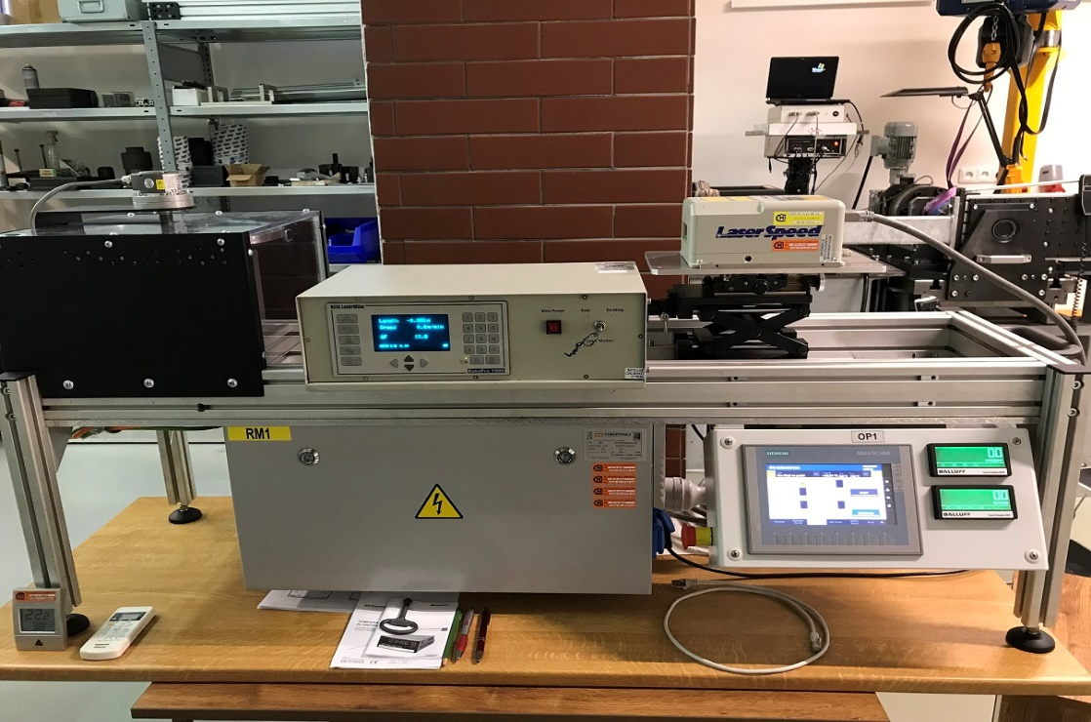

In case of any questions or interest in accredited calibration please will you contact the specialists of the Regional Inspectorate Kroměříž:
Ing. Tomáš Skopal, tskopal@cmi.cz , +420 606 647 633
Ing. Vít Petřík, vpetrik@cmi.cz, +420 602 524 170.

